***Ahmednagar Jilha Maratha Vidya Prasarak Samaj’s***

***NEW ARTS, COMMERCE AND SCIENCE COLLEGE, PARNER***



***Department of BBA (Computer Application)***

***A***

***Report***

***on***

***“****Pharmacy Management System****”***

*Submitted in*

*partial fulfillment of the requirement of the degree*

***BBA(Computer Application)***

***Under the guidance of***

*Prof.Shinde.R.A.*

***-: Submitted By:-***

*Miss.Auti Madhuri Dnyandev*

*To*

*Savitribai Phule Pune University,Pune*

*(2019-2020)*



**CERTIFICATE**

**DEPARTMENT OF BBA-CA**

This is to certify that ***Miss.Auti Madhuri Dnyandev*** **BBA** (Computer Application) has completed the Project titled **“*Pharmacy Management System*”** as per syllabus laid down by the Savitribai Phule Pune University during academic year 2019-20. He is sincere honest and complete the work allotted to him within stipulated time.

Her performance is ______________

**Internal Examiner External Examiner**

**Project Guide Head of Department**

***Acknowledgement***

*This Project Work is one of the courses allowed By Savitribai Phule Pune University, Pune Department of Computer Application students. It has really an excellent and wonderful experience to work on this project.*

*The Project Titled “Pharmacy Management System” would not have been completed without the valuable guidance and encouragement of Mr.Shinde sir. (Project Guide).*

*I am extremely thankful to Prof. Mr.Shinde sir (Head of Department of BBA-CA) And All Staff members for their guidance and moral support.*

*I am also thankful to our colleagues & all my classmates and friends for continuously inspiring me to complete this project.*

*Last but not least, I would like to pay our thanks to my parents and all Family members, without their support and Co-Ordination I would not able to complete this Project well in time.*

***Yours Sincerely***

***Miss.Auti Madhuri Dnyandev***

**INDEX**

|  |  |
| --- | --- |
| **Chapter No.** | **Contents.** |
| **1** | **INTRODUCTON** |
|  | Introduction |
|  | Existing System and Need for System |
|  | Scope of Work |
|  | Operating Environment Hardware and Software |
|  | Detail Description of Technology Used |
| **2** | **PROPOSED SYSTEM** |
|  | Proposed System |
|  | Objectives of System |
|  | User Requirements |
| **3** | **ANALYSIS AND DESIGN** |
|  | ERD |
|  | DFD |
|  | UML Diagram |
|  | Class Diagram |
|  | Use Case Diagrams |
|  | Activity Diagram |
|  | Sequence Diagram |
|  | Input Screens |
|  | Table Design |
|  | Test Procedure & implementation |
| **4** | **User Manual** |
|  | User Manual |
|  | Test case |
| **5** | **Drawbacks and Limitations** |
|  | Drawbacks |
|  | Limitations |
| **6** | **Proposed Enhancement** |
|  | Proposed Enhancement |
| **7** | **Conclusion** |
|  | Conclusion |
| **8** | **Bibliography** |
|  | Bibliography |

**Introduction**

This project concerned about developing a Pharmacy Management System that will be used for retail and wholesale pharmacies. The purpose of this project is to manage all data derived for a pharmacy to maintain their business through the system rather than recording their data manually which is more risk to the business to maintain and to avoid loss. According to my

Feasibility study of different pharmacies and recognized that most of them they recording their data manually through

Book of accounts. This type of recording data it makes them to incurred more loss and they are not able to determine if they incurred loss or not for those who having a large stock of medicine. There are a lot of discrepancies of items in the stock, it is hard for them even to recognise their all customer’s records; they cannot have even their weekly, monthly or a yearly report easily because of recording manually. Due to this challenges which cause to minimize a business profit I became with solution on how they can reduce risk and maximize their profit through Pharmacy management system.

**Background of the study**

Pharmacy management system is a system that consists of data entry, retrieval and monitoring stock, sale, customer records and management administrator’s records and determination of minimum quantity of each drug. String searching technique also applied in this system. This technique is referring by drugs name, drug code and description of drugs. Besides that, the system also provides two types of methods which are Quantity and Expire date of drugs.

Due to the size and quantity service of the pharmacy, the pharmacy has a very large customer base. The number of customers is quickly increases due to the increase of demand of drugs in many areas. This situation makes the pharmacist to be busy and use a lot of time to manage and control their business records. Meanwhile the pharmacist has to insure satisfaction in services to keep their records effectively at a reasonable time.

Pharmacy management deals with managing the medicine stock and selecting the suitable medicine needed by the customers. The core of pharmacist profession is the maintenance of quality and the subsequent implication for medical monitor and control in the pharmacy activities. The industry type of Pharmacy management system Medicine Selector for Pharmacy management System, or PMS is medical technology industry. The domain of this project is information Technology in healthcare. Within the growth of the information Communication Technology and Medical Technology, the system developers take this opportunity to help the pharmacist to manage stocks and select the medicine using computer program. PMS is developed to select the medicine for managing all of the medicine in pharmacy and other activities related with a pharmacy. This system also managing the selling process, customer records, and users’ records.

The module involve are medicine management module, medicine search module, selling process module, medicine list module, statistic of medicine sales module, date to date report module, and other Reports.

**Problem statement**

Improving performance and efficiency in pharmacy shops is a major goal of Pharmacy Management System. The transaction related to sales, maintaining of stocks records are maintained manually at present. These are to be automated and an application is required to relate of them relatively and logically so that the current system can be replaced and accepted without major changes and problems. The application will provide quick access to the records maintained and must reveal the important reviews about the business so that the growth can be easily compared and will provide with the various reports showing the related details that the important decisions could be taken easily.

The following are among of the problems that lead to propose creation and development of Pharmacy Management System Software.

There is no effectively management of information

Discrepancies of stock items.

It hard to determine stock balance.

Hard and Time consuming on preparation of daily, weekly, monthly, and yearly reports.

1.4 **Objective of the project**

The overall objective of this project is to establish a System for pharmacy shops so as to improve the performance and efficiency of pharmacy shops management. In order to achieve this goal effectively, there are some specific objectives should be implemented;

The following are specific objectives for this project.

* To provide easily accessibility of customers management
* To provide easily accessibility of sales reports
* To provide easily accessibility of stock reports
* To provide accessibility of debtors registration and review all your debtors
* To provide easily accessibility of Employees records etc.
* To provide easily accessibility of printing and prepare invoices for customers
* Printing of customers, debtors, and employees, sales, Purchases and all inventory reports.
* To minimise human errors.
* To provide optimal drugs inventory management by monitoring the drugs’ movement in the pharmacy unit.

1.5 **Significance of the study**

Pharmacy management system has its own significance to the pharmacy shops. Using this system, help to records all transaction made at the daily sales, it help to recognize all debtors, customers, employees, balance stock, etc. It manage all activities around the shop that increases productivity and maximize profit because a system is minimizing the risk of getting loss because all transaction recorded to the system and viewed if needed and the whole reports of the business will be shown at any time needed to be done.

**1.6 Scope**

The user of this system is being able to manage all necessary activities of the pharmacy shop. The information management that provided by the system is a great advantage to reduce records errors associated with pharmacy shops.

The system is handling all aspects of the inventory control function. It allow the Administrator, delete obsolete drugs and modify the current dosage and indications of a drug in the database.

Furthermore, the system will make the process of stock replenishment to be easily.

On the other hand, PMS is able to generate reports on the list of drugs in the stock for a given period of time. Also a system allow to know the expire date of drugs from early expire date to late expired in the stock. Although a Pharmacist is not able to delete, or update any items to database because he/she has no authority to do so, even to view or print any report, but the system allow him/her to sale and to see which items sold at the time.

Pharmacy Management System covered the following areas.

* Pharmacist management
* Sales management
* Stock management
* And reports management

**Operating Environment:**

**Client side Requirements:**

**Hardware:**

* PIV 2.8 GHz Processor and Above
* RAM 1 GB and Above
* HDD 40 GB Hard Disk Space and Above

**Software:**

**Front end: HTML, CSS, JavaScript**

HTML:

HTML is used to create and save web document. E.g. Notepad/Notepad++

CSS: (Cascading Style Sheets) Create attractive Layout

JavaScript:

It is a programming language, commonly use with web browsers.

**Back end:**

**PHP, MySQL**

PHP: Hypertext Preprocessor (PHP) is a technology that allows software developers to create dynamically generated web pages, in HTML, XML, or other document types, as per client request. PHP is open source software.

MySQL: MySQL is a database, widely used for accessing querying, updating, and managing data in databases.

**Software Requirement (Any One)**

WAMP Server

XAMPP Server

MAMP Server

LAMP Server

Machine Configuration:

* Dual Core 3.2 GHz
* 2 x 2 MB L2 cache
* 4 GB RAM

**Detail Description of Technology Used:**

# PHP

# Server-Side Scripting: Back-End Web Development Technology

When you type in a URL, lots of code is at work to bring a page to your screen. What connects your site’s database to the browser, creating a smooth, user-friendly experience? That’s the software built by **server-side scripts,** languages that build your site behind the scenes. The goal of this software? To provide a seamless experience for the user that’s as close to a desktop application as possible.

There are many server-side languages working toward that end goal. The language you choose for your site depends on a mix of your site’s requirements, your database/operating system setup, and the preferences of your development team. Knowing what each script can offer and what sets it apart is helpful in deciding how to build your back end, and who to hire.

The back end comprises three parts: the **server,** your [database](https://www.upwork.com/hiring/data/database-administrator-project-description/)**,** any **APIs**, and a **back-end web application,**software written via server-side languages. The server is a powerful computer that runs the back-end software, the database houses your site’s data, and the software communicates between the two. For example, if a user is updating a profile on a networking site, the server-side scripts will gather the information the user enters, the application will process it on the server, then interact with the database to update that information there.

Server-side scripts are used by [back-end web developers](https://www.upwork.com/hiring/development/back-end-web-developer/) to build the **back-end software**of a website—the mechanics we don’t see, but that make a site’s usability and functionality possible. These languages create the communication channel between user, server, and database. Anything that isn’t explicitly written into [the text markup of a site](https://www.upwork.com/hiring/development/the-basics-of-web-development/) is front-end or back-end software. Any data that a user requests in the browser (e.g., the fields in drop-down menus, photos, or user profiles) is delivered via server-side scripts, which create a channel between server and end user that requests, edits, and deletes things in the database. In the browser, [front-end scripts](https://www.upwork.com/hiring/development/how-scripting-languages-work/) make that information available to the user.

### **SERVER-SIDE SCRIPT BASICS**

* **Runs on a server,**embedded in the site’s code
* Designed to interact with back-end permanent storage, like databases, and process information from the server to access the database—like a direct line from user to database
* **Facilitates the transfer of data**from server to browser, bringing pages to life in the browser, e.g., processing and then delivering a field that a user requests or submits in a form
* **Runs on-call.**When a webpage is “called up,” or when parts of pages are “posted back” to the server with [AJAX](https://www.upwork.com/hiring/development/how-ajax-works/), server-side scripts process and return data
* **Powers functions in dynamic web applications,**such as user validation, saving and retrieving data, and navigating between other pages
* Plays a big role in how a database is built from the ground up and managed afterwards—an example of how roles often overlap in all aspects of development
* [PHP](https://www.upwork.com/hiring/development/php-frameworks-hiring-a-php-developer/)**:**The most popular server-side language on the web, PHP is designed to pull and edit information in the database. Its most commonly bundled with databases written in the SQL language. PHP was designed strictly for the web and remains one of the most widely used languages around. It’s easy to install and deploy, is staying competitive with lots of modern frameworks, and is the foundation for a number of content-management systems. PHP-powered sites: Word Press, Wikipedia, Facebook

# PhpMyAdmin

**PhpMyAdmin** is a free web application that provides a convenient GUI for working with the **MySQL** database management system. It is the most popular MySQL administration tool that is used by millions of users worldwide and has won numerous awards and honors.

Written in PHP, it has all common functions that you may need when developing a MySQL-based application or website. It also gave birth to several similar products, for example **phpPgAdmin** which provides similar functionality for the PostgreSQL DBMS.

## Overview of phpMyAdmin Capabilities

You can use phpMyAdmin for Windows or almost any other operating system ever existed. It can export and import database created and managed by MySQL DBMS, as well as work with some other data formats.

The list of supported formats includes SQL, CVS, CodeGen, CVS for Microsoft Excel, Microsoft Word 2000, JSON, LaTeX, MediaWiki Table, OpenDocument Spreadsheet, OpenDocument Text, PDF, PHP Array, Texy! Text and YAML data types.

## General Features

**With phpMyAdmin you can:**

* Create and remove users, manage user permissions
* Create, alter and drop databases, tables, fields and rows
* Search objects in the entire database or any particular tables
* Import and export data in different formats, including SQL, XML and CSV
* Monitor processes and track performance of different queries
* Execute custom SQL queries
* Back up your MySQL databases in manual mode

The tool is very simple to set up and use. It is usually installed on the same computer with MySQL database, so all commands are executed very quickly and don’t rely on network connectivity.

## Administering MySQL DBMS

While phpMyAdmin is a perfect tool for browsing the database, managing user privileges and executing SQL queries, it can’t be considered a full-featured administration tool.

Administration expects you to not only be able to work with an object, but also deal with unpredictable situations, such as SQL injections, user mistakes and other cases of database corruption. Especially it touches the matter of [automatic MySQL backup](https://www.handybackup.net/mysql-backup.shtml).

### Data Backup Problems of phpMyAdmin

The export/import functionality of phpMyAdmin lacks a lot of the features that you would expect to find in a backup software solution:

* **Scheduling.** With phpMyAdmin there is no way to export database data automatically.
* **Storage media support.** Since phpMyAdmin is a web-based software, you can work with it via browser only. This means that you can save backups only to local drives available on your system, via the **Save As...** dialog of your browser.
* **Compression, encryption, and other options.** The files exported with phpMyAdmin are saved as common text files, without any additional processing. Storing them in the original form usually occupies a lot of disk space, and is not secure.

**CHAPTER 2**

**Proposed System**

As far as the project is developed the functionality is simple, the objective of the proposal is to strengthen the functioning of Audit Status Monitoring and make them effective and better. The entire scope has been classified into five streams knows as Coordinator Level, management Level, Auditor Level, User Level and State Web Coordinator Level.

The proposed software will cover the information needs with respect to each request of the user group viz. accepting the request, providing vulnerability document report and the current status of the audit.

2.1.1 **Feasibility Study**

The purpose of feasibility study is to investigate deeply the recommended system. Feasibility study is carried out to describe and evaluate the proposed system. The study Will justify whether the project is feasible or not and whether it is worthwhile or not. Therefore, a feasibility study of the proposed system needs to be carried out in Order to:-

* Provide a better understanding of the System.
* Clarify objectives in the proposed System.
* Assess and recommend what course of action should be taken for the
* Solution proposed.
* Describe the outputs.

There are many factors to assess when analyzing whether the proposed system is Feasible and should be adopted. These factors are **Technical Feasibility, Operational Feasibility, Social Feasibility** and **Economical Feasibility.** In order to test Technical, Operational and Economical Feasibility, The system Comparisons are carried out between The Proposed System and The Existing System, so that the proposed system can be easily taken over.

**Technical Feasibility**

The Technical feasibility deals with some facts such as:-

* Is the proposed system technically feasible?
* Is it within the state of art?
* What hardware and software will be required?

Since company, it already has all the required hardware and software needed for the development of the proposed system. The backend is capable of handling multiple clients and voluminous data. The front-end withits effective and easy to use development tool will make the development easier and reliable. This means that the necessary technology that is required to perform development is readily available.

**Economic Feasibility:**

Cost-benefit analysis is a frequently used method for evaluating the effectiveness of the proposed system. It is important because management must authorize the budget of the project. It determines how the aims of the project can be achieved with limitedresources.The economic feasibility of the system is evaluated on the basis of the benefits of the proposed system. Costs included for implementation of proposed system are:

* Cost of additional hardware and software.
* Cost of product.

**Operational Feasibility**:

Operational feasibility deals with the human factor. It checks the impact of the proposed system on the job seeker Person. The management of the company has shown interest in the development of the system. They expect the computerized system to help them function more efficiently. The job seeker Person is computer literate and they have using computers for at least many years, thus they can be easily trained to work with the proposed system. Retrieval of information will be easier as all information will be stored in a database. The system will also be user friendly. Thus the proposed system is operational feasible.

**Social Feasibility:**

The proposed system is being implemented in multi-lingual varieties. Hence, languages used neither bears any alien terminologies it is made as far as localized as possible; nor the system contains any words that might hurt the sentiments of any user. User preferences and views are taken into consideration while designing the system. In all the system is socially feasible.

Objectives of Proposed System

**OBJECTIVE:**

The main goal of Pharmacy management system is to manage all records and transaction within the inventory and managing of sales. Pharmacy management System is a very effective tool for an organization to be efficient in business management. The traditional way of managing sales and inventory is performed by using a pen and a paper to write down the type and quantity of the stock. But errors in inventory records still exist even when the management uses IT systems and product data capturing technologies to improve the inventory systems. Inventory managers have to face inaccuracy of inventory records either at the store or at the warehouse level.

**CHAPTER 3**

**Analysis and Design**

#### ENTITY-RELATIONSHIP Diagrams

E-R (Entity-Relationship) Diagram is used to represents the relationship between entities in the table.

The symbols used in E-R diagrams are:

SYMBOL PURPOSE

Represents Entity sets.

Represent attributes.

Represent Relationship Sets.

Line represents flow

Structured analysis is a set of tools and techniques that the analyst.

To develop a new kind of a system:

The traditional approach focuses on the cost benefit and feasibility analysis, Project management, and hardware and software selection a personal considerations.

**ERD**

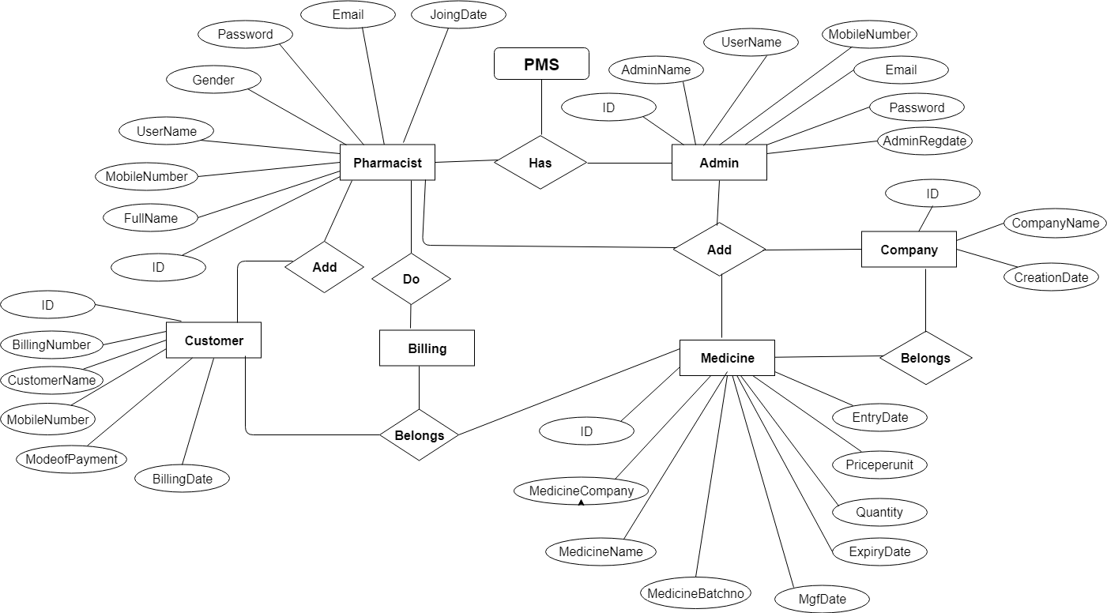

**Class Diagram:**

The class diagram shows a set of classes, interfaces, collaborations and their relationships.

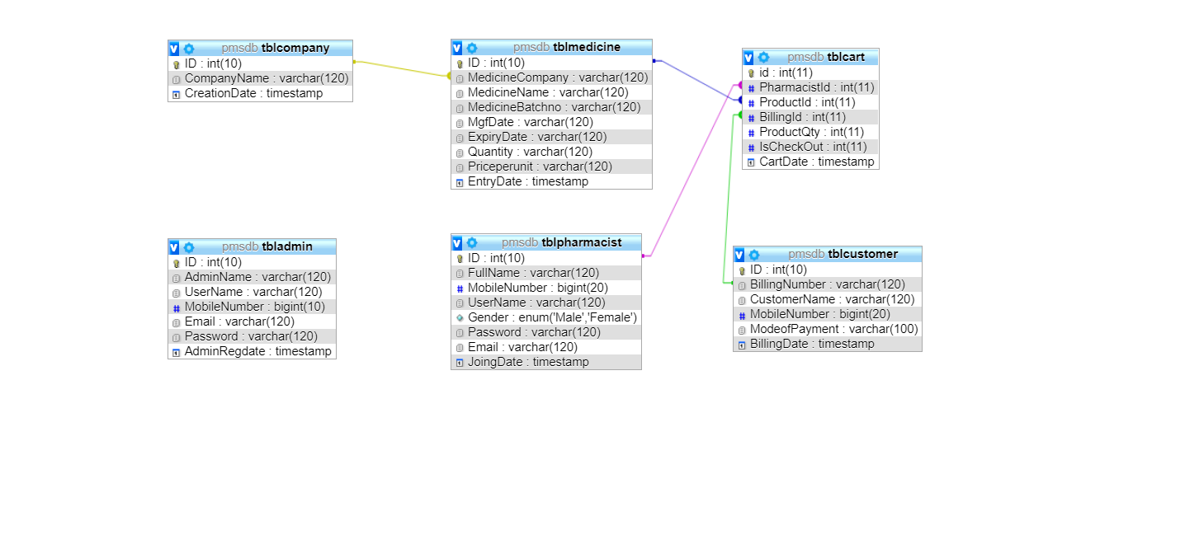

**Unified Modeling Language Diagrams(UML):**

* + The unified modeling language allows the software engineer to express an analysis model using the modeling notation that is governed by a set of syntactic semantic and pragmatic rules.
  + A UML system is represented using five different views that describe the system from distinctly different perspective. Each view is defined by a set of diagram, which is as follows.

**User Model View**

* + 1. This view represents the system from the users perspective.
    2. The analysis representation describes a usage scenario from the end-users perspective**.**

**Structural model view**

◆In this model the data and functionality are arrived from inside the system.

◆ This model view models the static structures.

**Behavioral Model View**

◆ It represents the dynamic of behavioral as parts of the system, depicting the interactions of collection between various structural elements described in the user model and structural model view.

**Implementation Model View**

* + In this the structural and behavioral as parts of the system are represented as they are to be built.

**Environmental Model View**

In this the structural and behavioral aspects of the environment in which the system is to be implemented are represented.

UML is specifically constructed through two different domains they are

* + UML Analysis modeling, which focuses on the user model and structural model views of the system?
  + UML design modeling, which focuses on the behavioral modeling, implementation modeling and environmental model views**.**

**Use Case flow Diagram (Pharmacist)**

**Pharmacist**

**Use Case flow Diagram (Admin)**

**Admin**

Activity Diagram

Login Activity Diagram



Add Event

Save Details

Enter Event name

Enter Fee, place

Add Event

Select Event

List of Event

Select Event

Admin

Logout

Event Participate List

View Event Team

Add new Event

View Event List

Login

Student

Logout

Login

View Event List

Update Profile

Select Event List

Register

Sequence Diagram

**Admin Login Form Sequence Diagram:**

: Admin

: login form

: login control

: Registration Table

enter usernmae

enter password

check username & password

if invalid

error message

fetch username and password

login successfully

+

**Student Login Form Sequence Diagram:**

: Student

: login form

: login control

: Registration Table

enter usernmae

enter password

check username & password

if invalid

error message

fetch username and password

login successfully

User Interface Design

Home Page

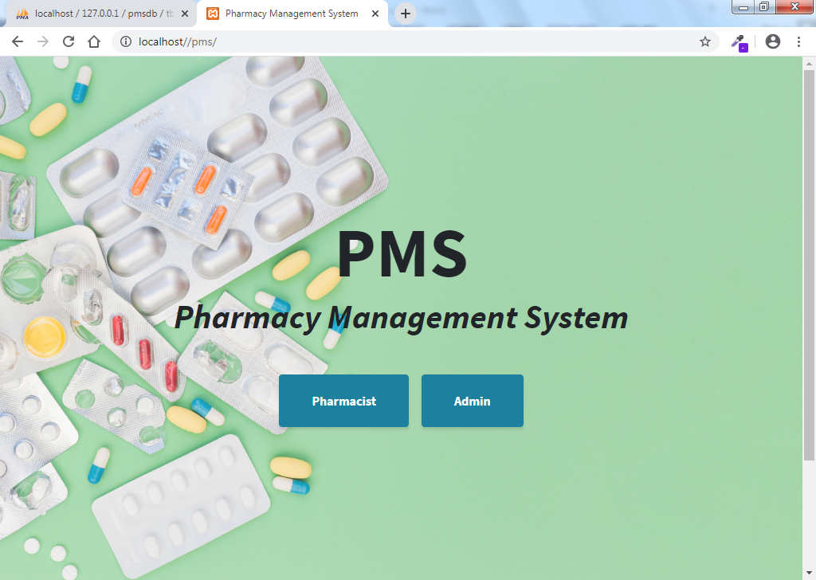

Admin Login

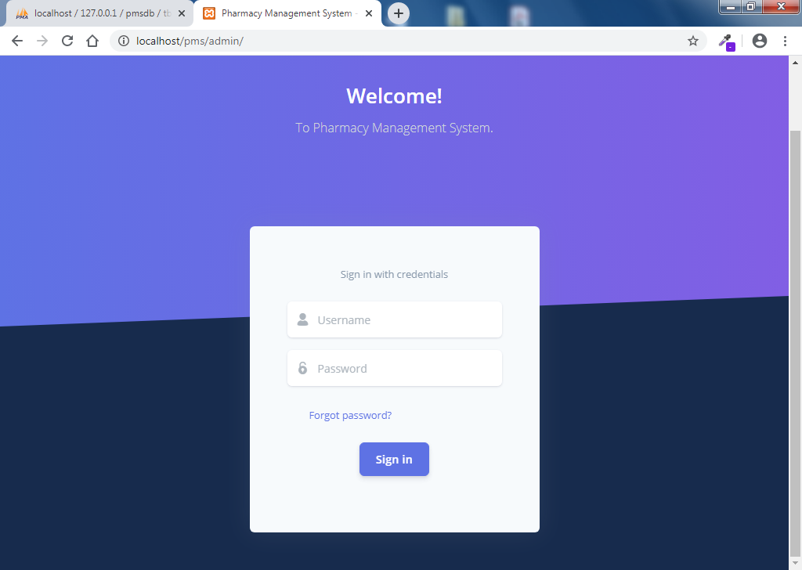

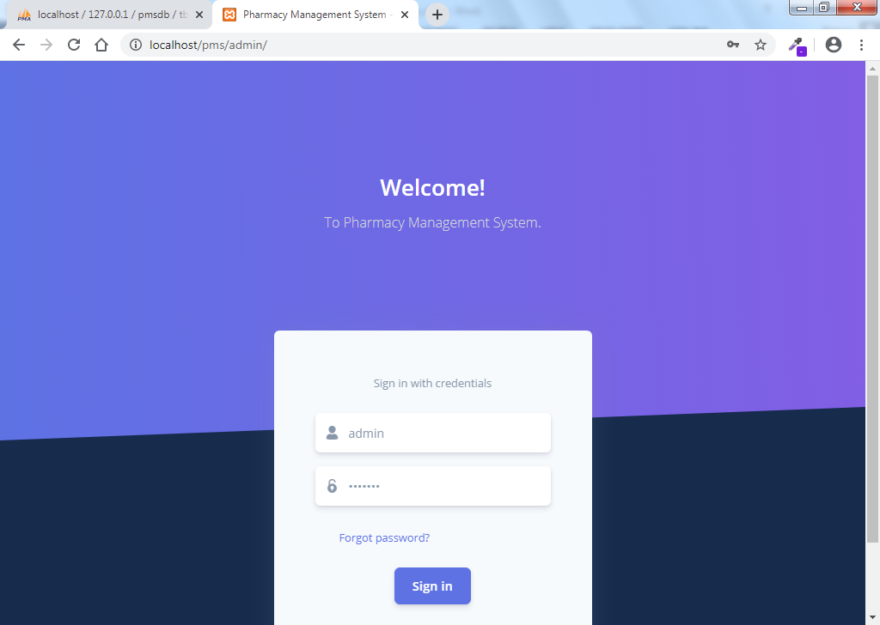

Admin Home Page

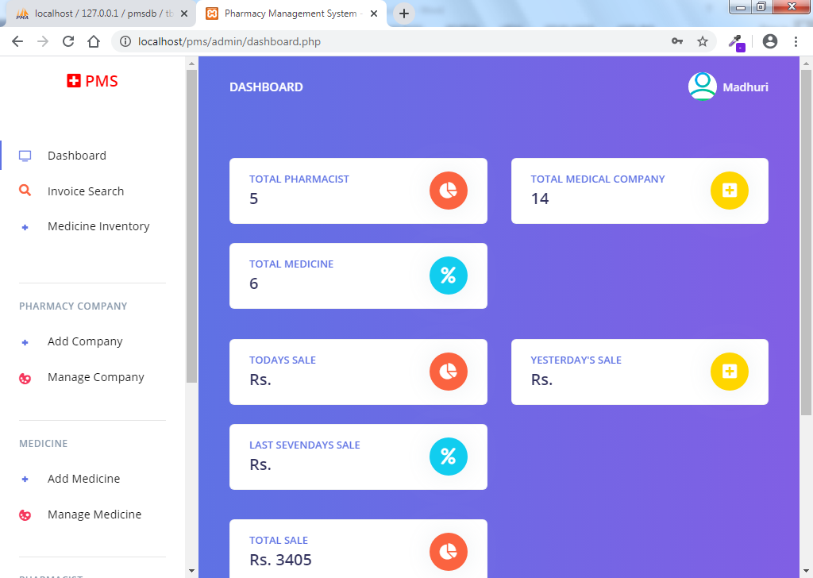

Compny Add

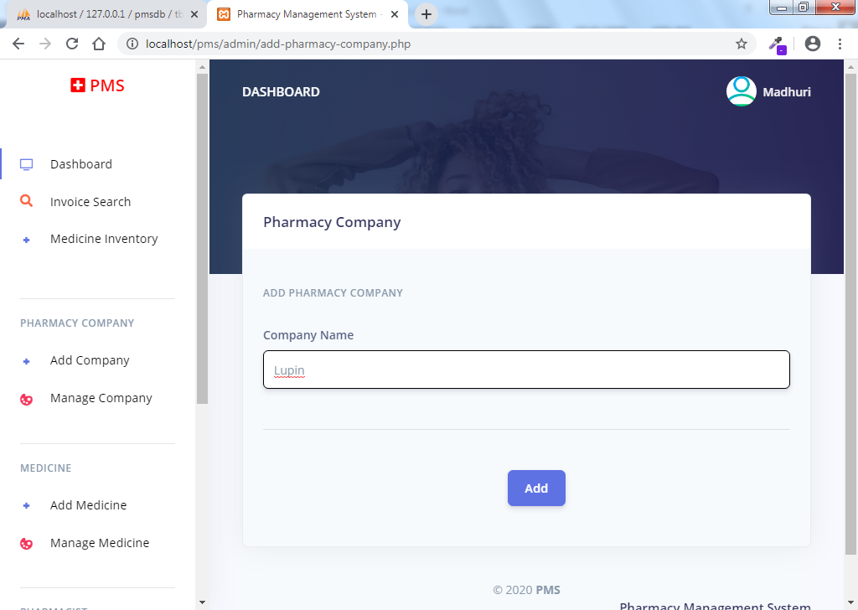

List of Company

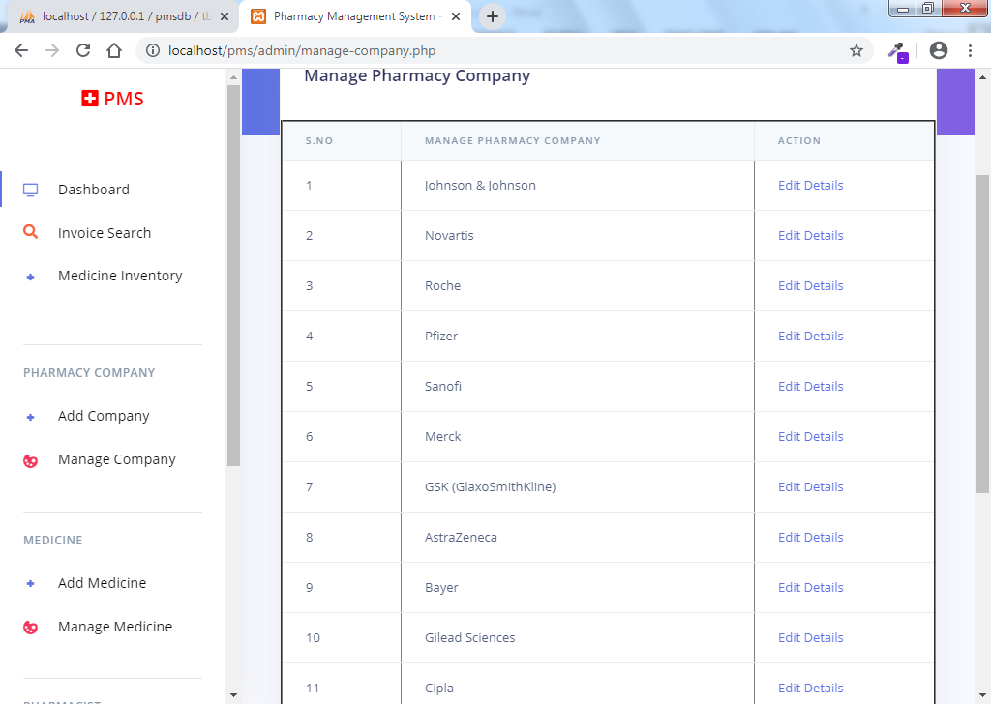

Add Medicne

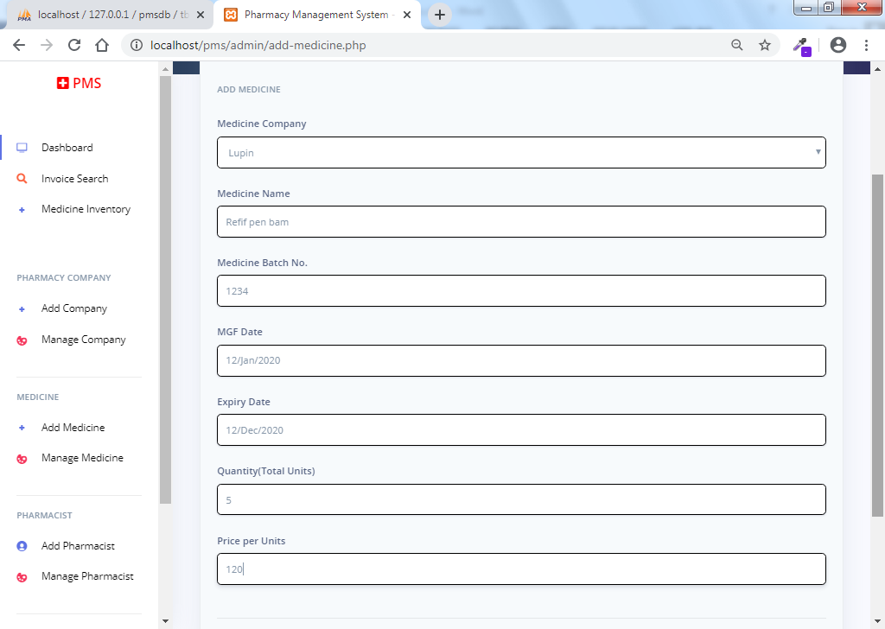

List of Medicine

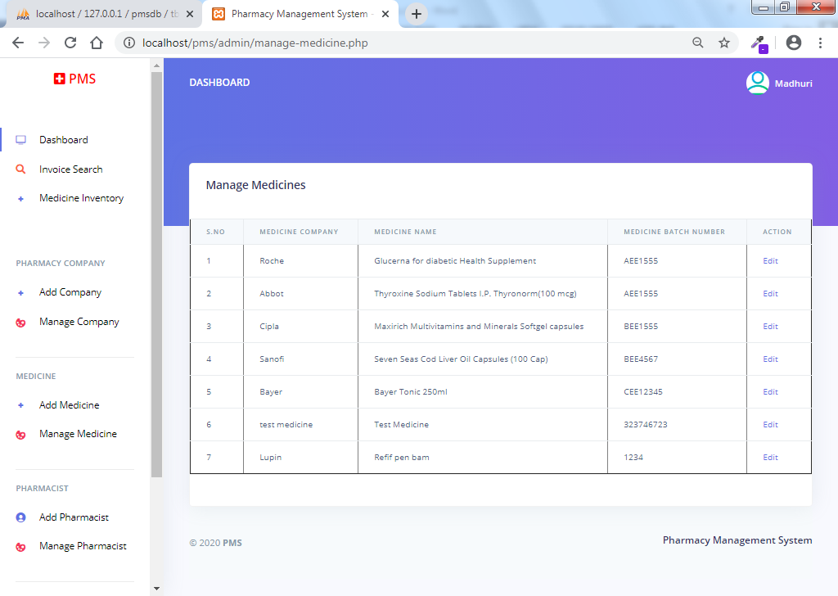

Add Pharmcist

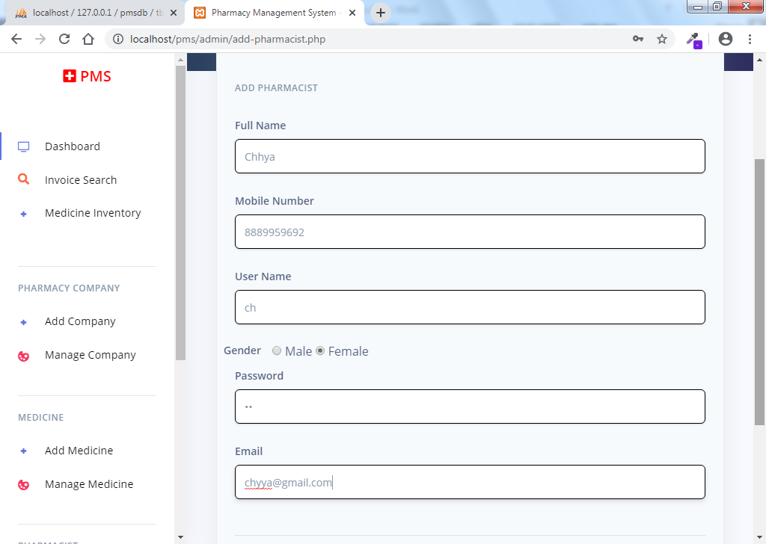

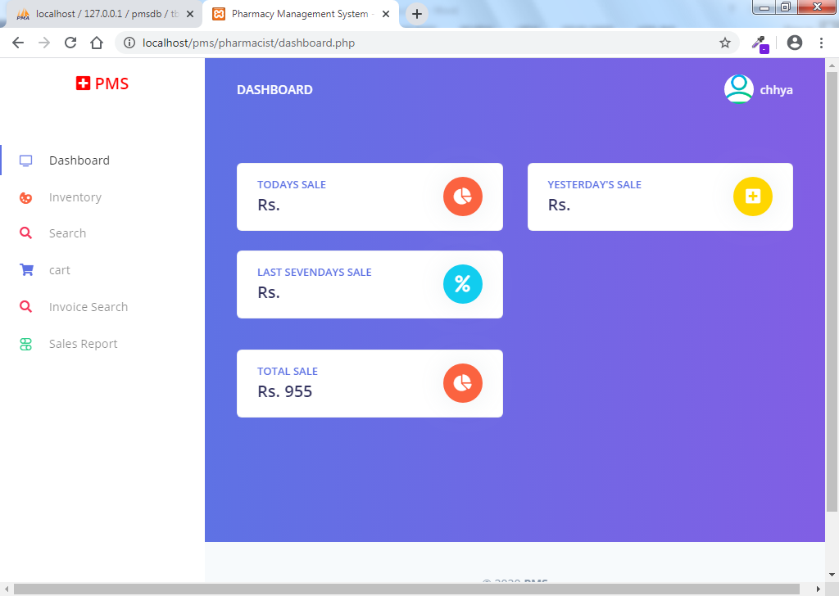

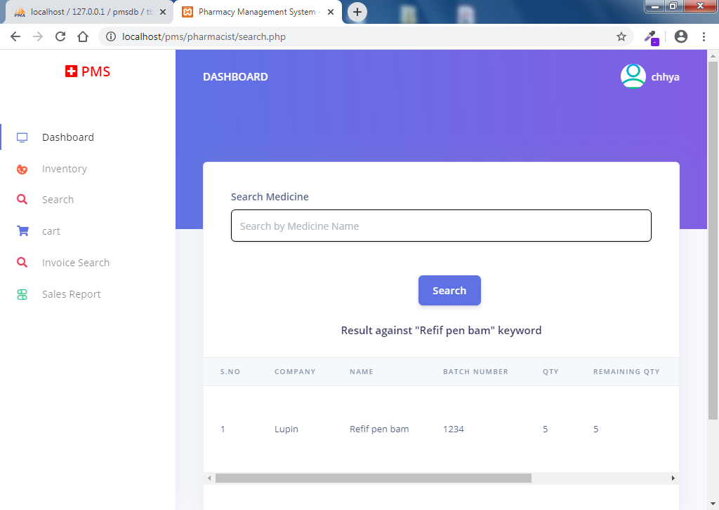

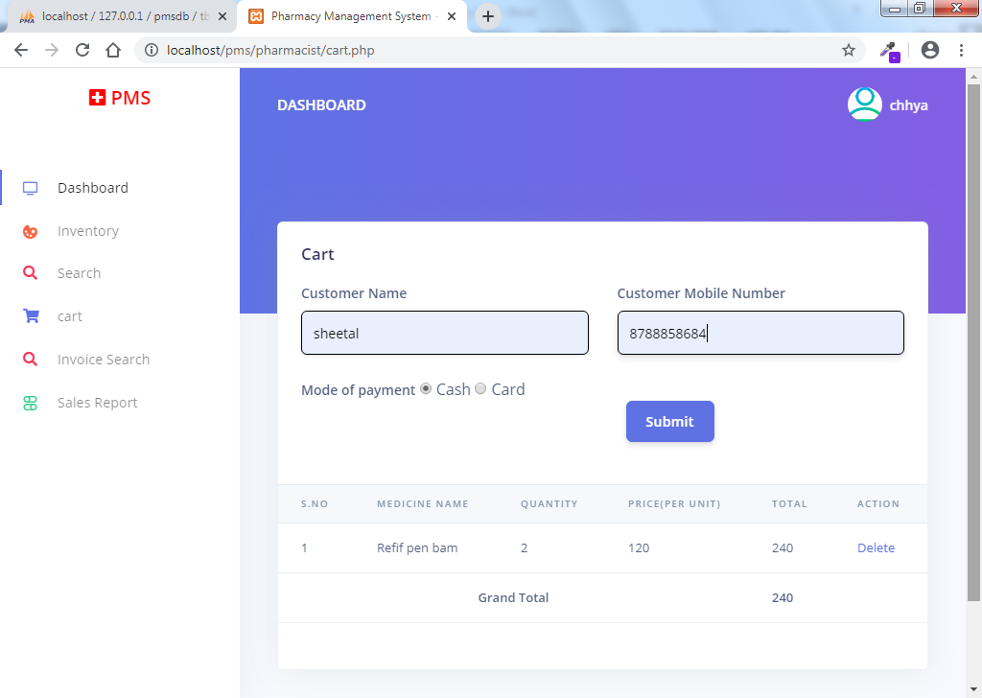

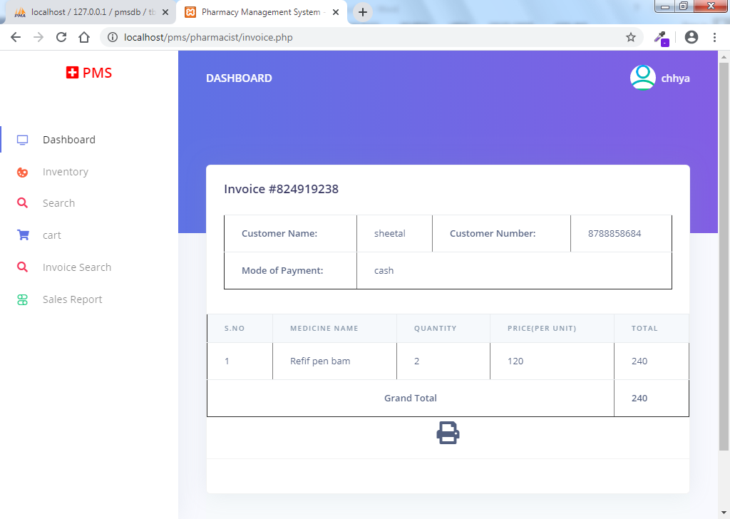

Table Specifications:

[**tbladmin**](http://localhost/phpmyadmin/sql.php?db=camsdb&token=0cdfa1f46252d35aec9fa851dd4c03bb&goto=db_structure.php&table=tbladmin&pos=0) **:** This table use to store admin login details.

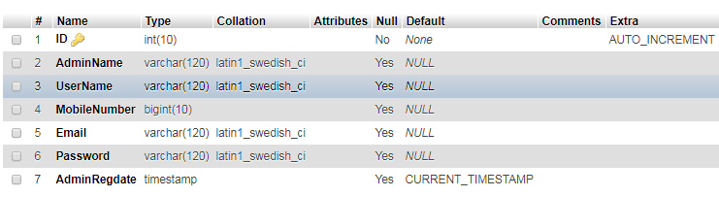

**tblcompany:** This table use to store medicine company details.

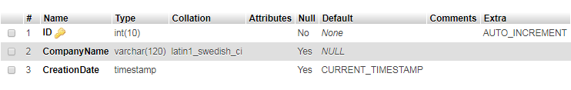

**tblmedicine :** This table use to store medicine details.

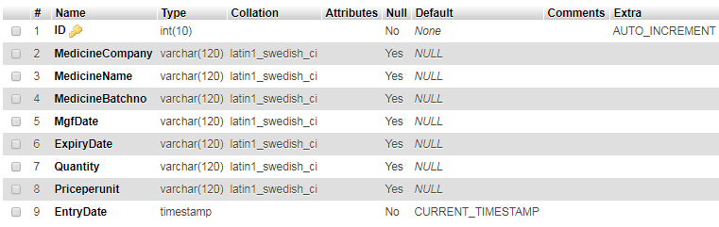

**tblpharmacist:** This table use to store pharmacist login details.

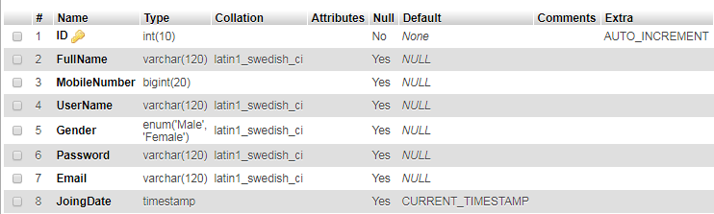

**tblcart:** This table use to store billing medicine details.

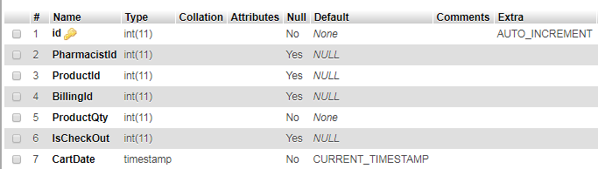

**tblcustomer:** This table use to store customer and final billing details.

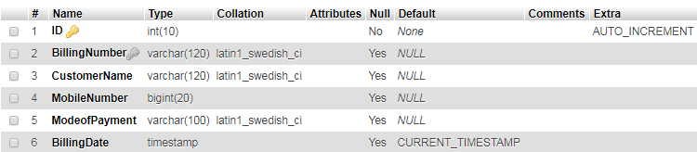

Any Software application being developed incorporates sequential steps of production activities where there is a high chance of creeping in an error in the data by human. As we say **“**To Err is human”. Errors may start creeping in the application at very early time of a process during requirement instigation phase i.e. when the objectives of the system are being defined. Errors may even drastically evolve at some later phase of the System Life cycle. Hence, software development must be done taking into consideration its development along with Quality assurance activity.

To assure the quality, it is highly necessary that the software being developed must have ample review of the product and the related documentation. It should ensure correctness, reliability, usability, integrity, efficiency in regards to its operations; it should also ensure to portability, reusability, interoperability in concern to the transition of the product, and lastly, it must also conform to the specifications of maintainability, flexibility, testability in tune with the product’s revision.

It also includes assurance, that the system meets the specification and the requirement for the intended usage and performance.

Quality assurance can be confirmed by:

* Testing
* Verification & Validation

TESTING: Testing presents an interesting anomaly for a software engineer. The engineer creates a series of test cases that are intended to “demolish” the software that has been built. Infect, testing is the one step in the software engineering process that could be viewed as destructive rather than constructive.

All testing activities that are carried in support to ONLINE COMPUTER SHOP are carried out keeping in mind the following things:

* All tests should be traceable to customer requirements
* Test should be planned before testing commences
* Initially testing should begin in small and gradually it should grow in shape

Following testing methodologies are adopted in the sequence:

* + Unit Testing,
  + Integration testing,
  + Validation testing,
  + System testing

UNIT TESTING: Unit testing is carried out by feeding data unit by unit in functions and is checked the modules / interfaces are tested to ensure that information properly flows in-and-out of each unit being tested. The local data was examined to ensure that the data store temporarily maintain its integrity during all steps in its execution. Boundary conditions were also tested to limit the extent of processing of the Boundary Values. All independent pats through control procedure were thoroughly exercised to ensure that all statements in the module gets executed at least once in the testing life-cycle. And finally, all error handling paths were tested.

VALIDATION TESTING: It was conducted to ensure that the system meets all the functional, behavioral, and performance requirements. Both alpha and beta testing were done at this phase i.e. at first dummy data were fed into the system and thereafter live data is fed and results were tested.

SYSTEM TESTING: Finally, a series of different tests whose primary objective is to fully exercise the system. All the modules were integrated and collectively tested to uncover errors in the operating interface. Several system tests were conducted like:

**Performance testing:** that includes like the site is parallel checked from IIS server at a time and is checked whether the response from the server is done properly or not.

**Load Testing:** The site is under gone several data loads and several data are made to store at a time and are tested.

**Security Testing:**The site is undergone security test by entering wrong username and or password. And that the user is made to enter in to other data without logging in and the user is directly made to enter the relative URL into the address bar of the browser.

VERIFICATION & VALIDATION TESTING: This testing runs the system in a simulated environment with simulated data. This test primarily looks for errors of commission and errors of omission. Regarding end user and design specification that were specified 1in the earlier phases but not fulfilled during construction.

Where in validation testing, the system is used with live data. The continuous usage of the system uncovers the bugs in the present system.

**Usability Testing:** Several users are made to work with the system in absence of any developers and tested whether all the users are going on correctly or not. Basically, it is tested for user-friendliness of the site, with estimation of training skills required, the time required to become moderately efficient in the usage of the system, and the net increase in productivity, and lastly the user attitude towards the site.

Drawbacks:

This site is a product of Human mind. Software Engineer develops software after long hours of analysis, evaluation and other SDLC functions. Still there can be limitations and drawbacks.

The Drawbacks of system are as follows:

* Computer being an electronic machine its feature are always incompatible to human being..
* Database backup is not possible.
* The users of the site cannot communicate online to each other.
* It requires an internet connection.
* It requires large database.

**Limitations:**

* The size of the database increases day-by-day, increasing the load on the database back up and data maintenance activity.
* Training for simple computer operations is necessary for the users working on the system.

.

Proposed Enhancement

We will enhance “**Collage Event System** “in following getaways.

* We will provide the student Register Event **System**.
* System will be developed functionality to send student event Details to admin
* System will be more user friendly than current position.

**Conclusions.**

It has been a great pleasure for me to work on this exciting and challenging project. This project proved good for me as it provided practical knowledge of not only programming in PHP and web based application and no some extent MYSQL, but also about all handling procedure related with **“Collage Event Management System”**

It also provides knowledge about the latest technology used in developing web enabled application and client server technology that will be great demand in future. This will provide better opportunities and guidance in future in developing projects independently.

**Bibliography**

* Joy of PHP Programming: A Beginner's Guide – by Alan Forbes.
* PHP & MySQL Novice to Ninja – by Kevin Yank. Learn
* JavaScript in a weekend by Jerry Lee Ford.
* Software Engineering by Roger Pressman.
* [www.google.com](http://www.google.com).
* [www.developers.com](http://www.developers.com)